Assignment 2 Web-technologies Kuanysh Beibarys SE-2413

Here, margins, padding, and borders were applied to adjust the layout and spacing of the sections.

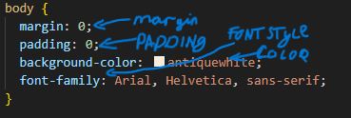

In this screenshot, element, class, and ID selectors were applied to style the webpage.

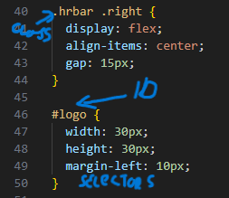

footer and header.

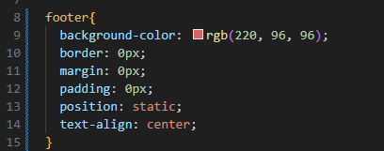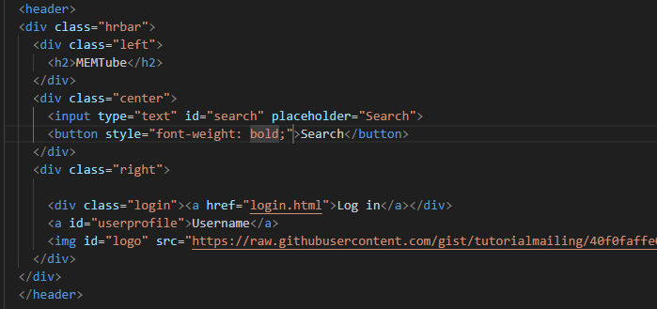

pseudo-elements (::before/::after) were used to decorate the heading, and smooth hover transitions were applied to buttons and links.

